* Open the email from ‘Microsoft on behalf of your organization’
* Click ‘Sign in to Office 365



* Sign in using the default password that was provided in the email

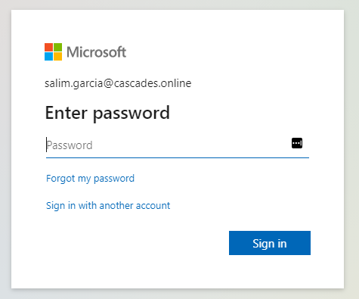

* Download the Microsoft Authenticator app on your phone, then click Next

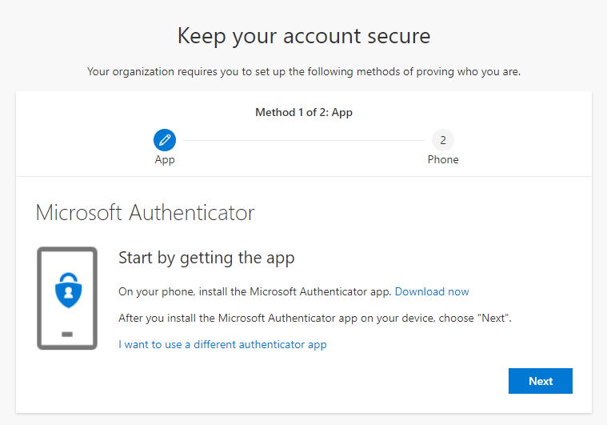

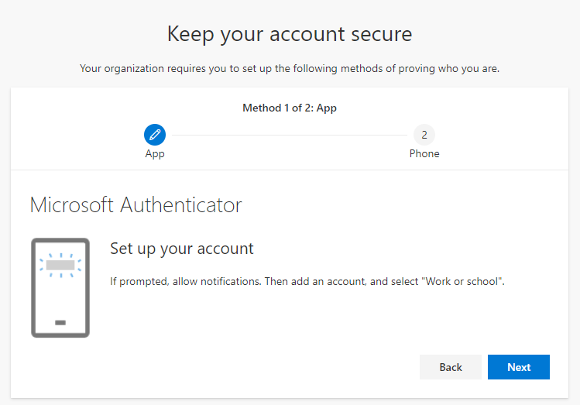

* Open the app and select ‘Scan a QR code’

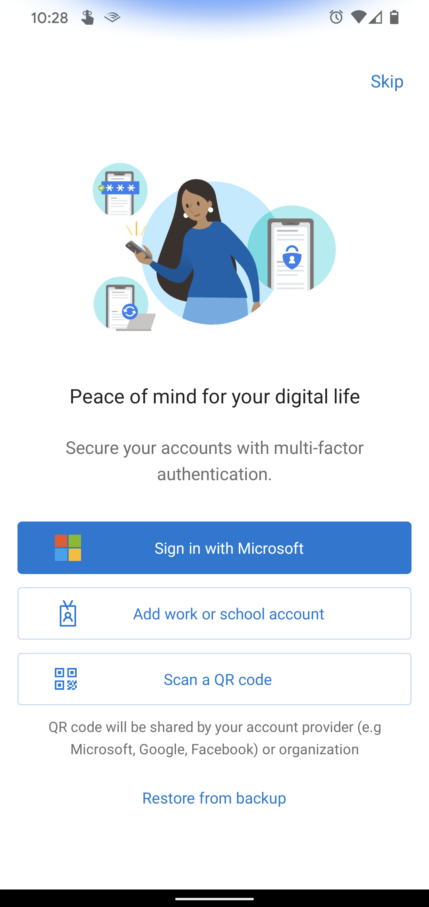

* Click ‘Next’ on the Cisnet Cascades website and you will be presented with a QR code. Scan the QR code with your phone to connect the Microsoft Authenticator app with your account

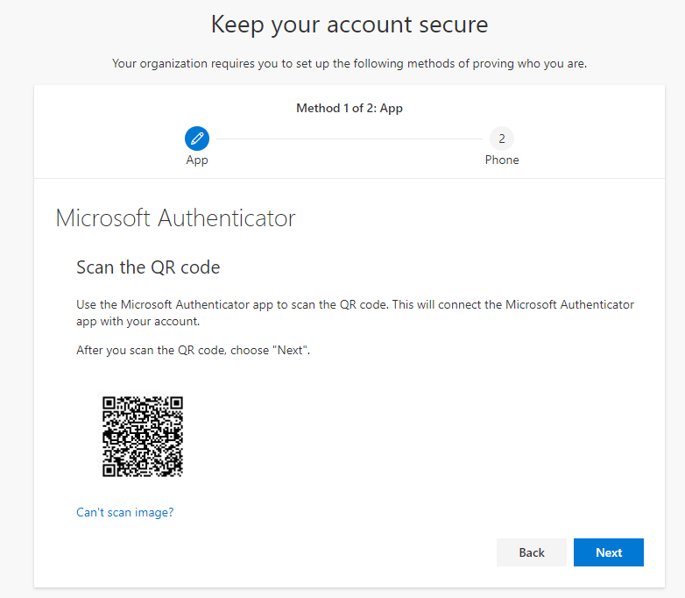

* At this point I scanned the QR code and got an error in the app. Then I tried scanning it again and got an error saying it had already been used
* I restarted the process by signing in from the link in the email with the default password
* I was prompted to set a new password, then I was redirected to the Microsoft Authenticator page
* I clicked next until I got to the QR code page again and was able to successfully scan the QR code with the app
* Then I tried clicking next on the QR code page, but I kept getting errors saying the Authenticator registration has timed out
* I tried restarting the process again but that still resulted in an error
* I then tried restarting the process in Edge instead of Chrome and was able to successfully scan the QR code and move past the QR code page
* Next I entered my phone number and opted to receive a text message authentication code, then entered the code
* I was then able to successfully log into my office 365 account